dbt Fundamentals – Review #1
Traditional Data Teams
- Data engineers are responsible for maintaining data infrastructure and the ETL process for creating tables and views.
- Data analysts focus on querying tables and views to drive business insights for stakeholders.
ETL and ELT
- ETL (extract transform load) is the process of creating new database objects by extracting data from multiple data sources, transforming it on a local or third party machine, and loading the transformed data into a data warehouse.
- ELT (extract load transform) is a more recent process of creating new database objects by first extracting and loading raw data into a data warehouse and then transforming that data directly in the warehouse.
- The new ELT process is made possible by the introduction of cloud-based data warehouse technologies.
dbt
- dbt empowers data teams to leverage software engineering principles for transforming data.
- The focus of this course is to build your analytics engineering mindset and dbt skills to give you more leverage in your work.
The Analytics Development Lifecycle (ADLC)
- Provides a structured process for building, testing, reviewing, and deploying analytics.
- Encourages iteration and collaboration so teams can confidently move from idea to production.
- Aligns data work with software engineering best practices—version control, testing, and continuous improvement.
dbt as the Data Control Plane
- dbt orchestrates and governs the ADLC across your data ecosystem.
- It ensures consistency in how data is developed, tested, documented, and deployed.
- By serving as the “control plane,” dbt integrates with the modern data stack to enforce trust, scalability, and readiness for AI-driven use cases.
dbt Fundamentals – Review #2
Models
- Models are .sql files that live in the models folder.
- Models are simply written as select statements - there is no DDL/DML that needs to be written around this. This allows the developer to focus on the logic.
- In dbt Studio, the Preview button will run this select statement against your data warehouse. The results shown here are equivalent to what this model will return once it is materialized.
- After constructing a model, dbt run in the command line will actually materialize the models into the data warehouse. The default materialization is a view.
- The materialization can be configured as a table with the following configuration block at the top of the model file:
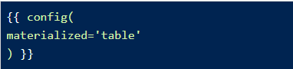
- The same applies for configuring a model as a view:
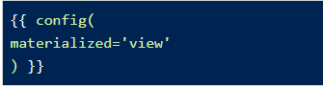
- When dbt run is executing, dbt is wrapping the select statement in the correct DDL/DML to build that model as a table/view. If that model already exists in the data warehouse, dbt will automatically drop that table or view before building the new database object. *Note: If you are on BigQuery, you may need to run dbt run --full-refresh for this to take effect.
- The DDL/DML that is being run to build each model can be viewed in the logs through the dbt interface or the target folder.
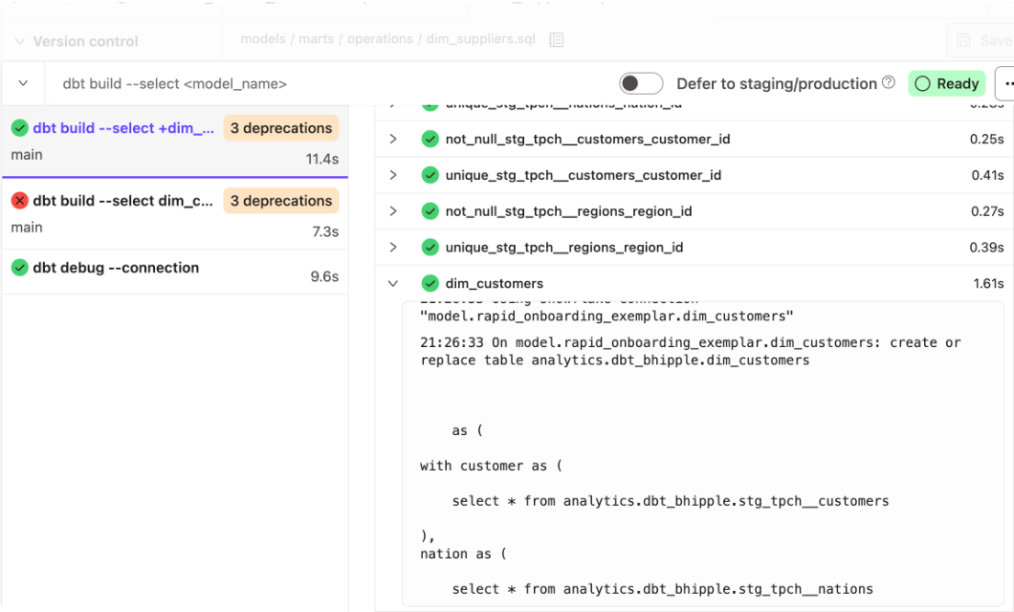
Modularity
- We could build each of our final models in a single model as we did with dim_customers, however with dbt we can create our final data products using modularity.
- Modularity is the degree to which a system's components may be separated and recombined, often with the benefit of flexibility and variety in use.
- This allows us to build data artifacts in logical steps.
- For example, we can stage the raw customers and orders data to shape it into what we want it to look like. Then we can build a model that references both of these to build the final dim_customers model.
- Thinking modularly is how software engineers build applications. Models can be leveraged to apply this modular thinking to analytics engineering.
ref Macro
- Models can be written to reference the underlying tables and views that were building the data warehouse (e.g. analytics.dbt_jsmith.stg_jaffle_shop_customers). This hard codes the table names and makes it difficult to share code between developers.
- The ref function allows us to build dependencies between models in a flexible way that can be shared in a common code base. The ref function compiles to the name of the database object as it has been created on the most recent execution of dbt run in the particular development environment. This is determined by the environment configuration that was set up when the project was created.
- Example: {{ ref('stg_jaffle_shop_customers') }} compiles to analytics.dbt_jsmith.stg_jaffle_shop_customers.
- The ref function also builds a lineage graph like the one shown below. dbt is able to determine dependencies between models and takes those into account to build models in the correct order.
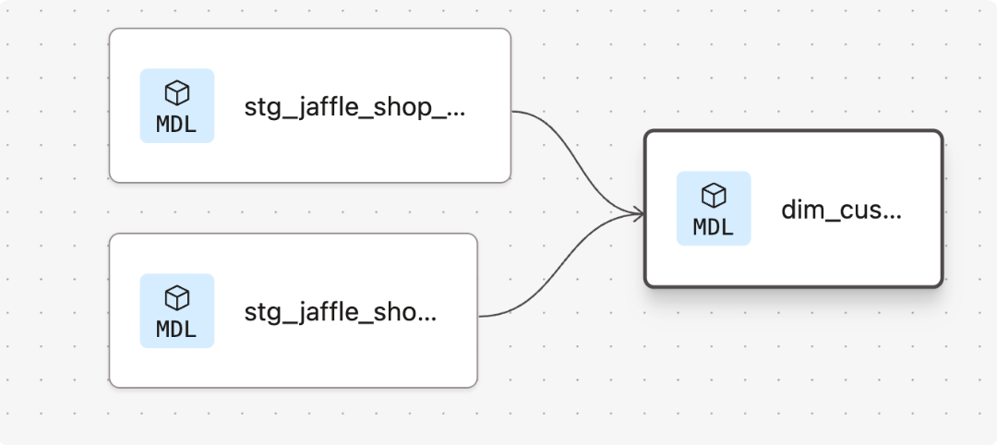
Modeling History
- There have been multiple modeling paradigms since the advent of database technology. Many of these are classified as normalized modeling.
- Normalized modeling techniques were designed when storage was expensive and computational power was not as affordable as it is today.
- With a modern cloud-based data warehouse, we can approach analytics differently in an agile or ad hoc modeling technique. This is often referred to as denormalized modeling.
- dbt can build your data warehouse into any of these schemas. dbt is a tool for how to build these rather than enforcing what to build.
Naming Conventions
In working on this project, we established some conventions for naming our models.
- Sources (src) refer to the raw table data that have been built in the warehouse through a loading process. (We will cover configuring Sources in the Sources module)
- Staging (stg) refers to models that are built directly on top of sources. These have a one-to-one relationship with sources tables. These are used for very light transformations that shape the data into what you want it to be. These models are used to clean and standardize the data before transforming data downstream. Note: These are typically materialized as views.
- Intermediate (int) refers to any models that exist between final fact and dimension tables. These should be built on staging models rather than directly on sources to leverage the data cleaning that was done in staging.
- Fact (fct) refers to any data that represents something that occurred or is occurring. Examples include sessions, transactions, orders, stories, votes. These are typically skinny, long tables.
- Dimension (dim) refers to data that represents a person, place or thing. Examples include customers, products, candidates, buildings, employees.
- Note: The Fact and Dimension convention is based on previous normalized modeling techniques.
Reorganize Project
- When dbt run is executed, dbt will automatically run every model in the models directory.
- The subfolder structure within the models directory can be leveraged for organizing the project as the data team sees fit.
- This can then be leveraged to select certain folders with dbt run and the model selector.
- Example: If dbt run -s staging will run all models that exist in models/staging. (Note: This can also be applied for dbt test as well which will be covered later.)
- The following framework can be a starting part for designing your own model organization:
- Marts folder: All intermediate, fact, and dimension models can be stored here. Further subfolders can be used to separate data by business function (e.g. marketing, finance)
- Staging folder: All staging models and source configurations can be stored here. Further subfolders can be used to separate data by data source (e.g. Stripe, Segment, Salesforce). (We will cover configuring Sources in the Sources module)
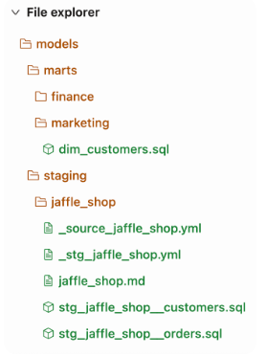
dbt Fundamentals – Review #3
Sources
- Sources represent the raw data that is loaded into the data warehouse
- We can reference tables in our models with an explicit table name (raw.jaffle_shop.customers).
- However, setting up Sources in dbt and referring to them with the sourcefunction enables a few important tools.
  - Multiple tables from a single source can be configured in one place.
  - Sources are easily identified as green nodes in the Lineage Graph.
  - You can use dbt source freshness to check the freshness of raw tables.
Configuring sources
- Sources are configured in YML files in the models directory.
- The following code block configures the table raw.jaffle_shop.customers and raw.jaffle_shop.orders:
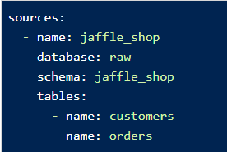
- View the full documentation for configuring sources on the source properties page of the docs
Source function
- The ref function is used to build dependencies between models.
- Similarly, the source function is used to build the dependency of one model to a source.
- Given the source configuration above, the snippet {{ source('jaffle_shop','customers') }} in a model file will compile to raw.jaffle_shop.customers.
- The Lineage Graph will represent the sources in green.
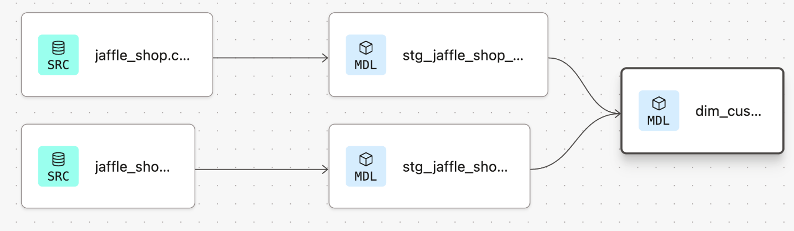
Source freshness
- Freshness thresholds can be set in the YML file where sources are configured. For each table, the keys loaded_at_field and freshness must be configured.
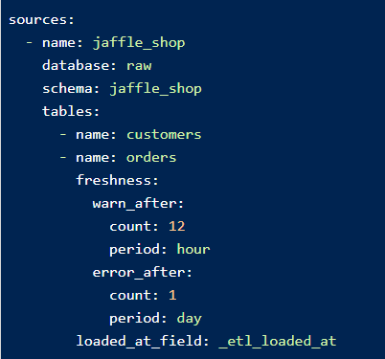
- A threshold can be configured for giving a warning and an error with the keys warn_after and error_after.
- The freshness of sources can then be determined with the command dbt source freshness.
dbt Fundamentals – Review #4
Testing
- Testing is used in software engineering to make sure that the code does what we expect it to.
- In Analytics Engineering, testing allows us to make sure that the SQL transformations we write produce a model that meets our assertations.
- In dbt, tests are written as select statements. These select statements are run against your materialized models to ensure they meet your assertations.
Tests in dbt
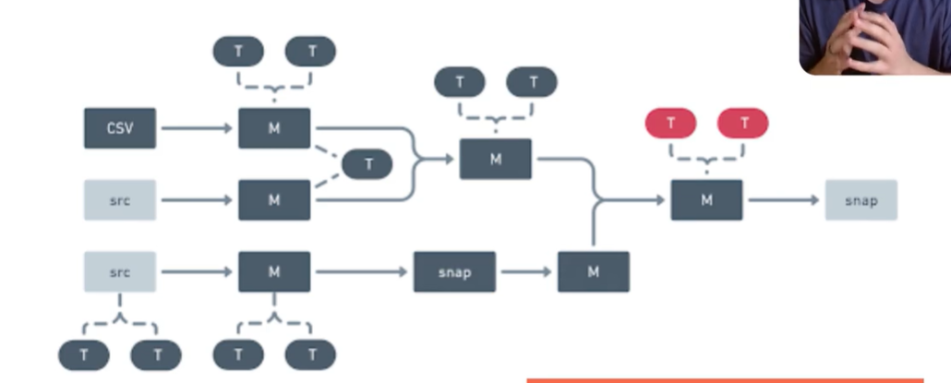
In dbt, there are two types of tests – generic & singular tests:
- Generic tests are a way to validate your data models and ensure data quality. These tests are predefined and can be applied to any column of your data models to check for common data issues. They are written in YAML files.
Example: This source has freshness checks configured using the _updated_at column that issues a warning if the source hasn’t been updated for more than 1 day, and raises an error if it hasn’t been updated for more than 7 days.
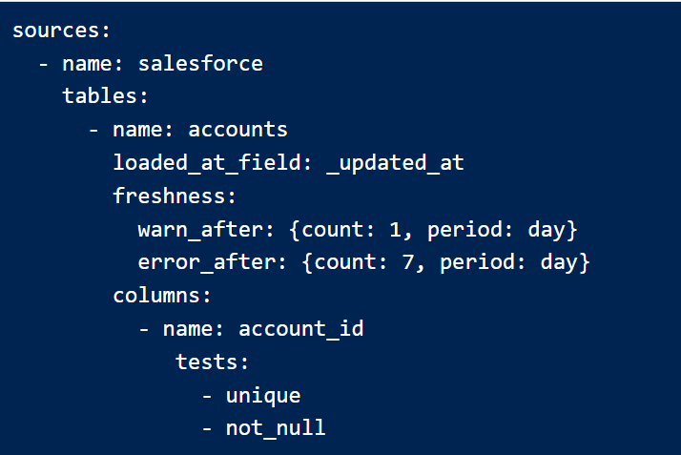
- Singular tests are data tests defined by writing specific SQL queries that return records which fail the test conditions. These tests are referred to as "singular" because they are one-off assertions that are uniquely designed for a single purpose or specific scenario within the data models.
dbt ships with four built-in tests: unique, not null, accepted values, relationships.
- Unique tests to see if every value in a column is unique
- Not_null tests to see if every value in a column is not null
- Accepted_values tests to make sure every value in a column is equal to a value in a provided list
- Relationships tests to ensure that every value in a column exists in a column in another model
Tests can be run against your current project using a range of commands:
- dbt test: runs all tests in the dbt project
- dbt test --select test_type:generic
- dbt test --select test_type:singular
- dbt test --select one_specific_model
Bonus: dbt seed – Loads CSV data into your warehouse tables, dbt snapshot – Tracks slowly changing dimensions in your data.
In development, dbt will provide a visual for your test results. Each test produces a log that you can view to investigate the test results further.

Worked Example
Assume your project only has models and sources and data tests configured on models and sources, dbt build will first test your sources, then materialize and test each model in DAG order.
dbt Fundamentals – Review #5

Documentation Basic
Documentation
- Documentation is essential for an analytics team to work effectively and efficiently. Strong documentation empowers users to self-service questions about data and enables new team members to on-board quickly.
- Documentation often lags behind the code it is meant to describe. This can happen because documentation is a separate process from the coding itself that lives in another tool.
- Therefore, documentation should be as automated as possible and happen as close as possible to the coding.
- In dbt, models are built in SQL files. These models are documented in YML files that live in the same folder as the models.
Writing documentation and doc blocks
- Documentation of models occurs in the YML files (where generic tests also live) inside the models directory. It is helpful to store the YML file in the same subfolder as the models you are documenting.
- For models, descriptions can happen at the model, source, or column level.
- If a longer form, more styled version of text would provide a strong description, doc blocks can be used to render markdown in the generated documentation.
dbt Fundmentals – Review #6
Development vs. Deployment
- Development in dbt is the process of building, refactoring, and organizing different files in your dbt project. This is done in a development environment using a development schema (dbt_jsmith) and typically on a non-default branch (i.e. feature/customers-model, fix/date-spine-issue). After making the appropriate changes, the development branch is merged to main/master so that those changes can be used in deployment.
- Deployment in dbt (or running dbt in production) is the process of running dbt on a schedule in a deployment environment. The deployment environment will typically run from the default branch (i.e., main, master) and use a dedicated deployment schema (e.g., dbt_prod). The models built in deployment are then used to power dashboards, reporting, and other key business decision-making processes.
- The use of development environments and branches makes it possible to continue to build your dbt project without affecting the models, tests, and documentation that are running in production.
Creating your Deployment Environment
- A deployment environment can be configured in dbt on the Orchestration > Environments page.
- General Settings: You can configure which dbt version you want to use and you have the option to specify a branch other than the default branch.
- Data Warehouse Connection: You can set data warehouse specific configurations here. For example, you may choose to use a dedicated warehouse for your production runs in Snowflake.
- Deployment Credentials:Here is where you enter the credentials dbt will use to access your data warehouse:
  - IMPORTANT: When deploying a real dbt Project, you should set up a separate data warehouse account for this run. This should not be the same account that you personally use in development.
  - IMPORTANT: The schema used in production should be different from anyone's development schema.
Scheduling a job in dbt
- Scheduling of future jobs can be configured in dbt on the Jobs page.
- You can select the deployment environment that you created before or a different environment if needed.
- Commands: A single job can run multiple dbt commands. For example, you can run dbt run and dbt test back to back on a schedule. You don't need to configure these as separate jobs.
- Triggers: This section is where the schedule can be set for the particular job.
- After a job has been created, you can manually start the job by selecting Run Now
Reviewing Jobs
- The results of a particular job run can be reviewed as the job completes and over time.
- The logs for each command can be reviewed.
- If documentation was generated, this can be viewed.
- If dbt source freshness was run, the results can also be viewed at the end of a job.

dbt - Project Initialization
- python -m venv .venv | Create virtual environment
- .venv\Scripts\Activate
- pip install uv
- uv init -> uv sync
- uv add dbt-core, dbt-databricks
- uv pip freeze > requirements.txt - Save all library names for download
- dbt init
- dbt debug - dbt run - dbt clean

Model Selection
General run: dbt run
Run on specific models: dbt run --select "X Y” – X and Y indicating the schema name (dbt run --select "bronze_customer bronze_date”)
Run on specific schema: dbt run --select “models/X” – X indicating the folder layer (dbt run --select “models/bronze”)

Model Configuration
Configuration location | Scope | Typical use | Precendence
dbt_project.yml | Project / folder | Default settings for many models | Lowest
properties.yml | Individual model | Selective configuration alongside metadata | Medium
{{ config(...) }} block in the model SQL | Individual model | Configuration tightly coupled to the SQL logic | Highest
Example On Model Configuration
dbt_project.yml
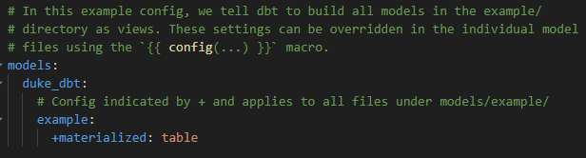
models/bronze/properties.yml
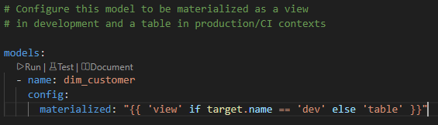
models/bronze/bronze_product.sql
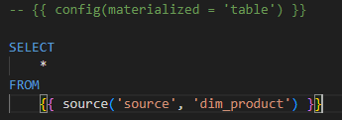
When to use each
dbt_project.yml
- Defaults for folders or the whole project.
- Example: all staging models are views.
properties.yml
- Metadata (descriptions, tests, contracts, versions).
- Model-specific configuration that you want centralized with the model's documentation.
- Good for static settings like materialized, tags, or grants.
config() block
- Configuration that is closely related to the SQL implementation.
- Useful when configuration depends on Jinja logic or is easier to understand in the context of the model.

Automatic model’s schema name generation
dbt uses a default macro called generate_schema_name to determine the name of the schema that a model should be built in.
The following code represents the default macro's logic (Removing {{ default_schema }}_ to create respective layer names – bronze, silver, gold):
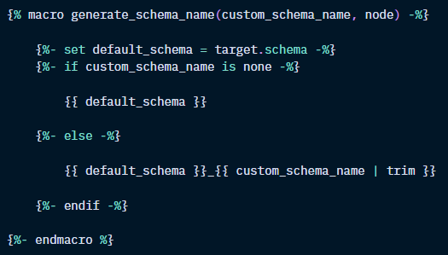

Snapshots – SCD2 Type
Snapshots implement type-2 Slowly Changing Dimensions over mutable source tables. These Slowly Changing Dimensions (or SCDs) identify how a row in a table changs over time
This feature is particularly useful when analysts often need to maintain a history of changes in mutable tables. For example, if a customer’s address or status changes, snapshots retain both the previous and current values, which allows you to analyze historical data and understand how records have evolved over time.
In simple terms
Without snapshots:
customer_id | status
1 | Premium
If the status changes from Basic → Premium, the Basic value is lost.
With snapshots:
customer_id | status | dbt_valid_from | dbt_valid_to
1 | Basic | 2024-01-01 | 2024-06-30
1 | Premium | 2024-07-01 | NULL
This allows you to answer questions such as:
- What was the customer's status last month?
- When did the customer become Premium?
- How many customers changed plans this year?

